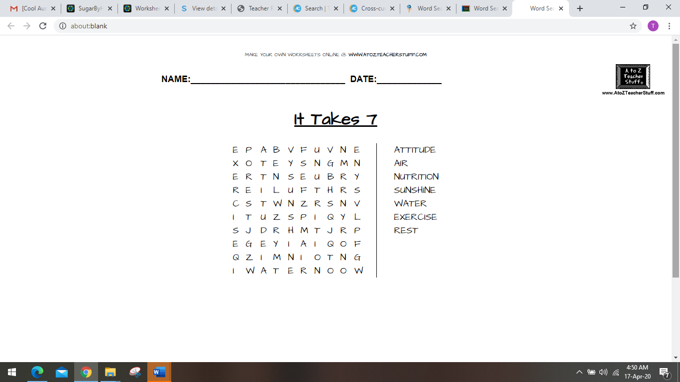

<https://tools.atozteacherstuff.com/word-search-maker/wordsearch.php>